**"Error of Power supply and Power Supply of Cable"**

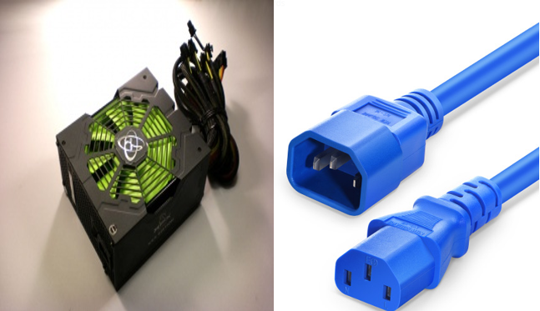

**1.The steps that you followed to identify the fault.**

When open the computer, the monitor and the window are not occurred. The power supply fan does also not work. In this addition, all the fans on motherboard are also not work and another bulb on motherboard are not light, too.

**2.Cause of the Fault.**

This problem can be the error of power supply damage or power supply cable broken. It also can be the cable is not detected with power supply.

**3.The step taken to remedy the fault.**

First, look to the cable is detect to power supply or not. Then, check the cable broken or not. If these two ways are not fine this is error of cable. You can replace the cable again to detect well. Remove the damage cable and replace new one. If the power supply is damage have to repair or get new one and replace it.

**4.The success or failure of the repair.**

By doing this way the fans and other hardware will be work. The monitor will appear signals. And you will see the window run. Successful.

**"Loose dust of Memory error"**

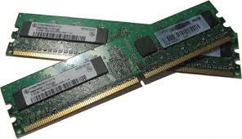

**1.The steps that you followed to identify the fault.**

When start the computer sometime it displays memory error. Sometimes only appear blue death screen on the monitor. And the sound beat one short two longs beat is notified.

**2.Cause of the Fault.**

This is possible error. It will be the memory loose from slot or loose of dust. You can repair is easily.

**3.The step taken to remedy the fault.**

Shutdown the window and unplugged all. And open the motherboard and clean all the dust from memory careful. Also clean all the dust from slots. Then, replace the memory in the slot carefully.

**4.The success or failure of the repair.**

Turn on the computer and the window will run well. The process of repair memory is success.

**"error of 0xc00007b or 0xc000007b"**

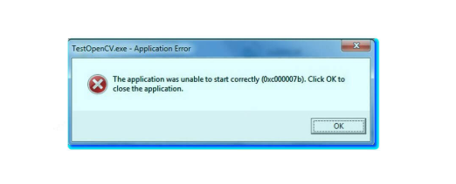

**1.The steps that you followed to identify the fault.**

When try to run execute any applications or games on windows, then 0xc00007b or 0xc000007b error is suddenly appear on window screen and the execute tasks are stop.

**2.Cause of the Fault.**

The PC have window 32bits application that tries to load 64bits DLL. Because of mixing the 32bits setting with 64bits, this error is occurred. This error can commonly occur in the Microsoft System and can often happen in any version of windows 7 to 10.

**3.The step taken to remedy the fault.**

To execute of any applications run as an administrator. First, right click on the application you want to execute and click Properties. In the properties dialog box go to Compatibility label. Mark on Run this program as an administrator and then click ok. You also can install DirectX and fix it. Because some software requires DirectX software.

**4.The success or failure of the repair.**

Solving of this 0xc000007b is success. Now, can execute application well.

**Test Plan Identifier**

I need to train my using keyboard skill for do assignment in Ubuntu. I install Ubuntu OS in my computer. Because I need to use keyboard and mouse. So, I test input keyboard and input mouse. I want to know how my keyboard and mouse are perform highly quality or not. And also want to know which keypads are not work. In Ubuntu OS there are ready contain testing tools.

**Introduction**

From many of components, I want to know my keyboard and mouse are work high quality. So, I use the system software that already include in Ubuntu and I will use this software for testing. If we know the result of keyboard and mouse testing, we can repair them easy which place are not good.

Open the search bar and search "system testing" to test keyboard and mouse. Then, double click it and open.

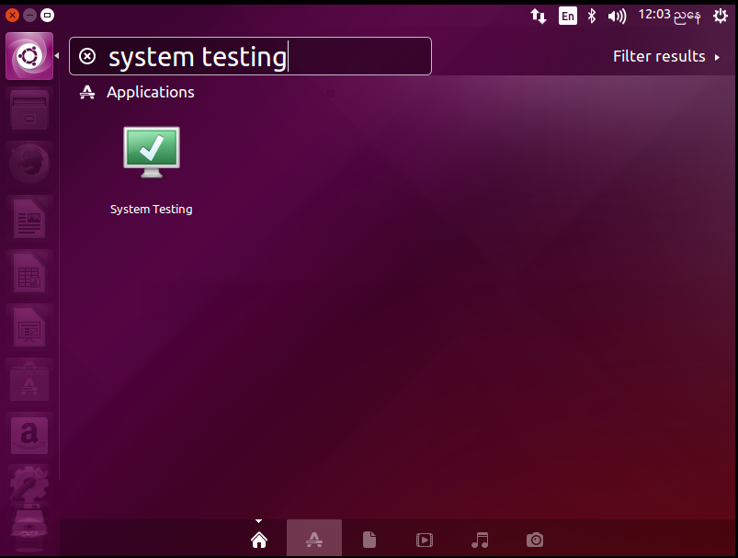

Figure(2.2b.1)

And you will see the "Welcome of System Testing". Next click Continue.

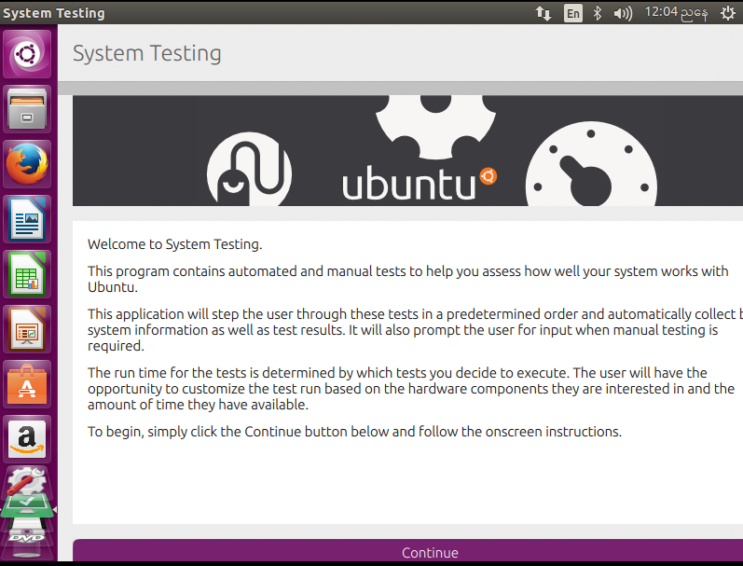

Figure(2.2b.2)

Mark the "Default" and click ok to be next step.

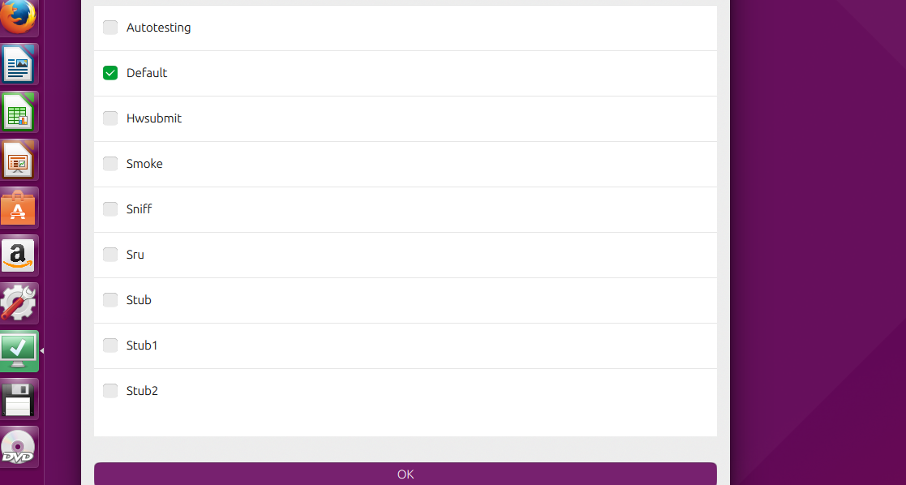

Figure(2.2b.3)

There are many components which one you want to. Among of them, I select input keyboard and input mouse. Because I want to test my keyboard and mouse. After selected click Start Testing.

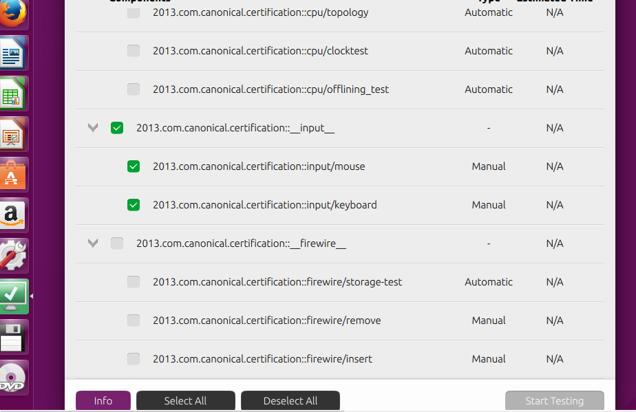

Figure(2.2b.4)

This is Manual Test of input/keyboard. If you want to Test tick yes and click test.

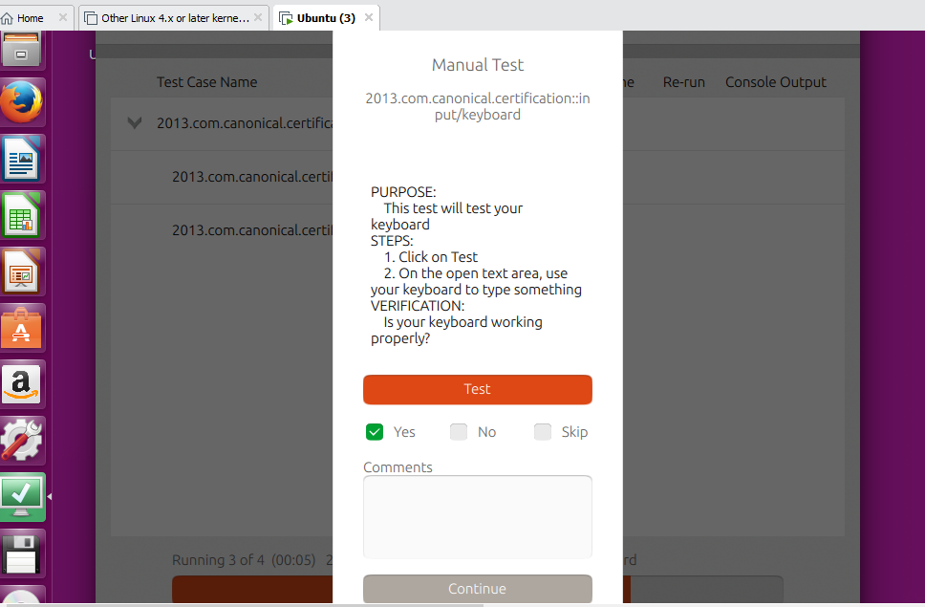

Figure(2.2b.5)

Here you can type all of your keypad and test it which one are not well.

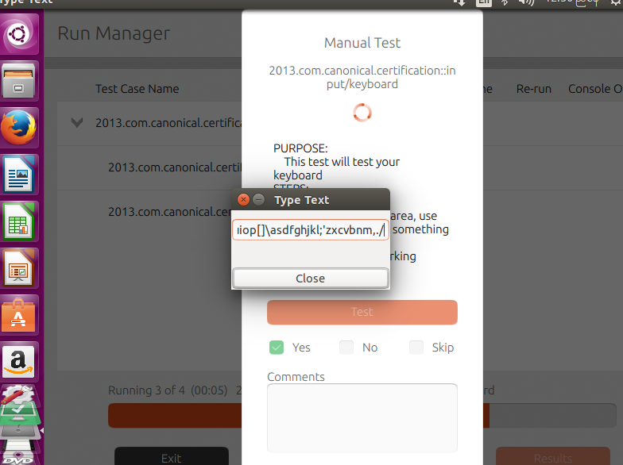

Figure(2.2b.6)

And this is for test mouse because the is already fine. So, you cannot click yes. Then, click continue.

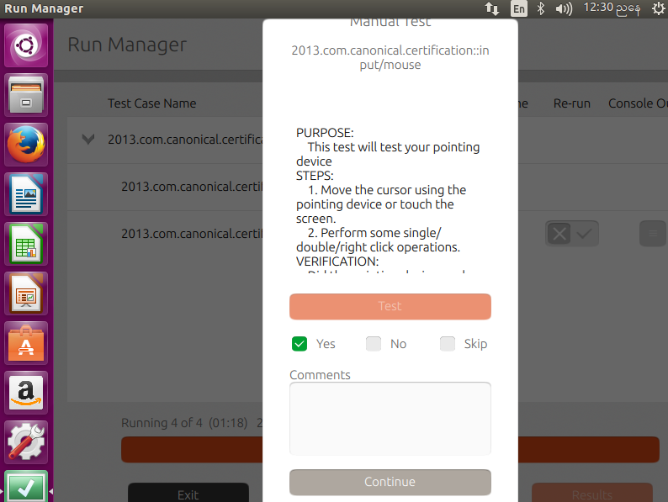

Figure(2.2b.7)

The following screen means the task you have test is complete and success. The keyboard and mouse are performed well. You can also look results. If you want to look click Results.

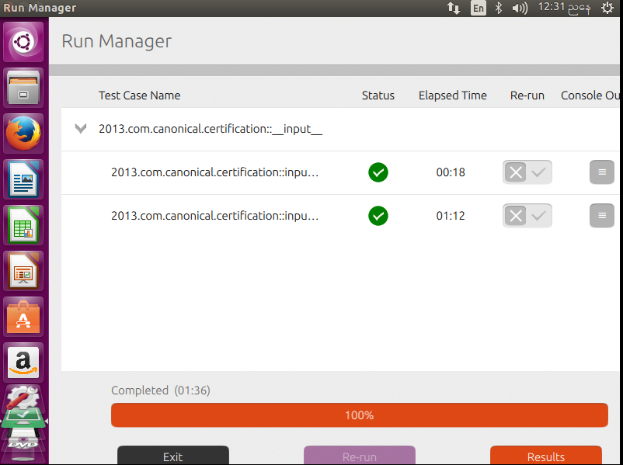

Figure(2.2b.8)

To view the results, click in the View Results.

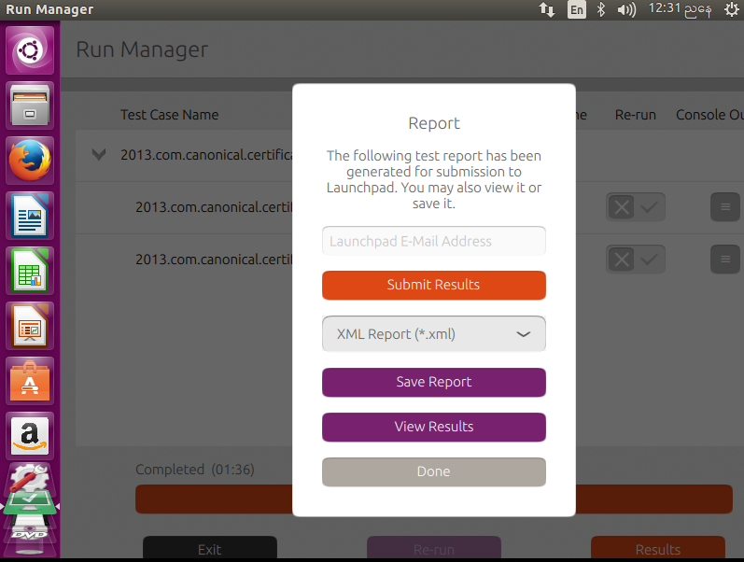

Figure(2.2b.9)

This is the tests performed screen. The result is passed.

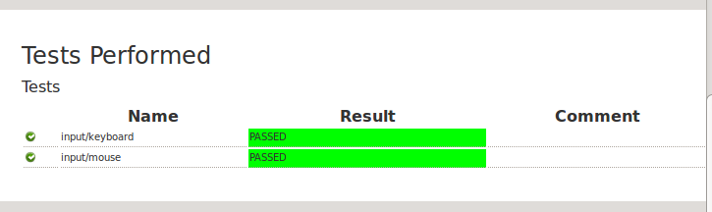

Figure(2.2b.10)

First place the Ubuntu CD in the CD-ROM and run it. And you have to wait for a while for the Ubuntu Linux installation to appear.



Fig(2.1a.1)

**Step 1-**You will see the Welcome box. Select the language you understand and choose "Install Ubuntu".

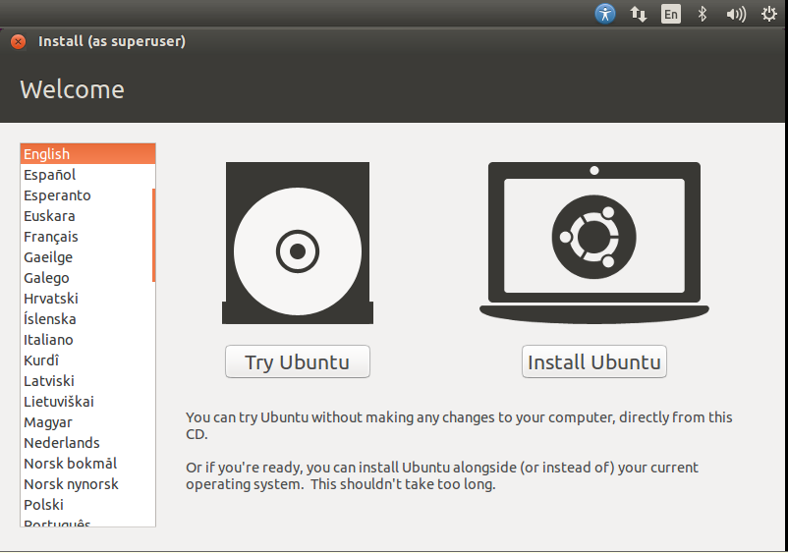

Fig(2.1a.2)

**Step 2-**After that click Continue.

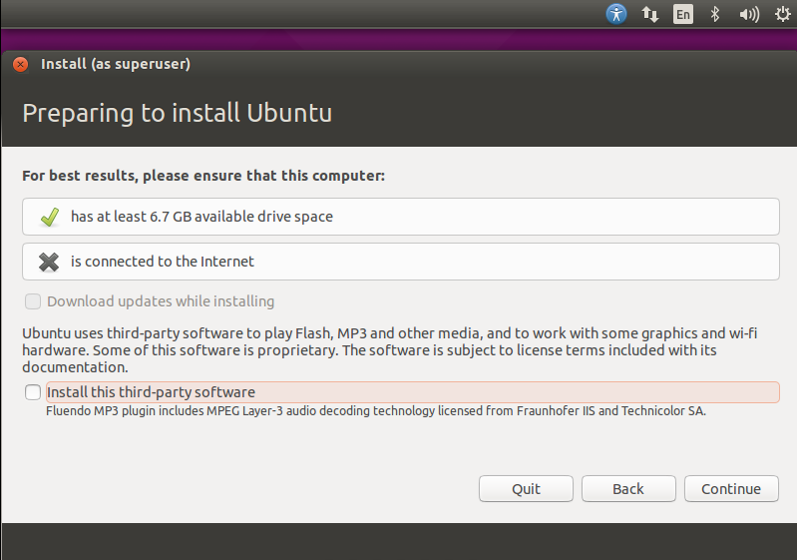

Fig(2.1a.3)

**Step 3-** If you want to partition select the Something else. You also can choose as you like. For this I want to erase all document, videos, images, programs, music and other files in operation system. So, I select "Erase disk and Install Ubuntu". Then, click Install Now.

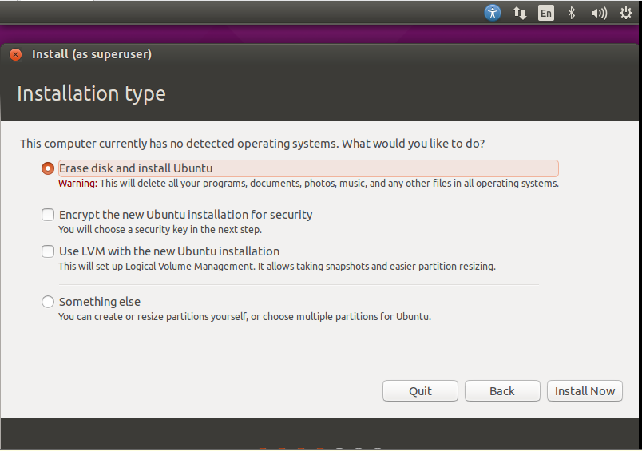

Fig(2.1a.4)

**Step 4-** And click Continue to go next step.

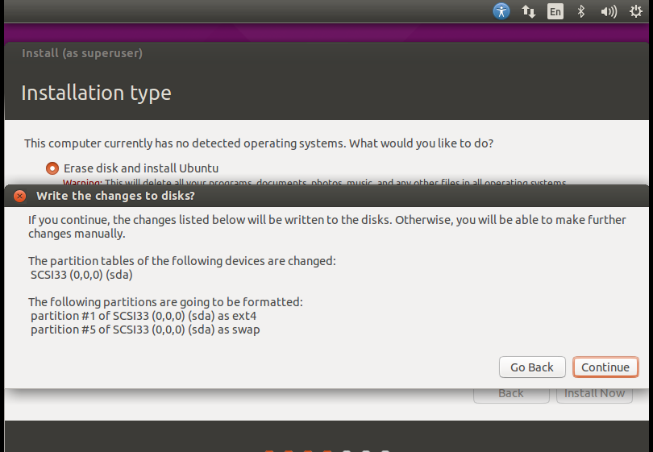

Fig(2.1a.5)

**Step 5-** Choose the region you live. Then, click "Continue".

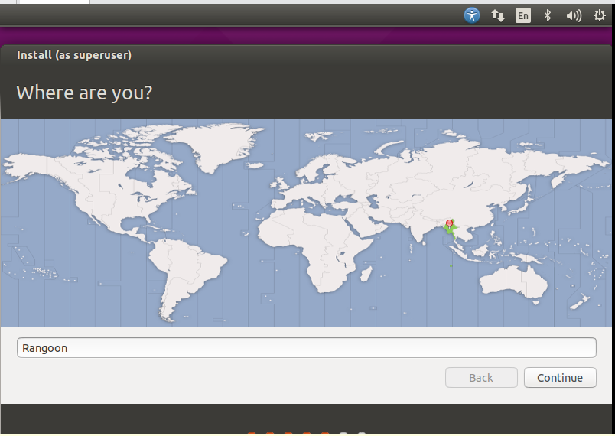

Fig(2.1a.6)

**Step 6-** This step is to select the keyboard layout that you want to use and click Continue.

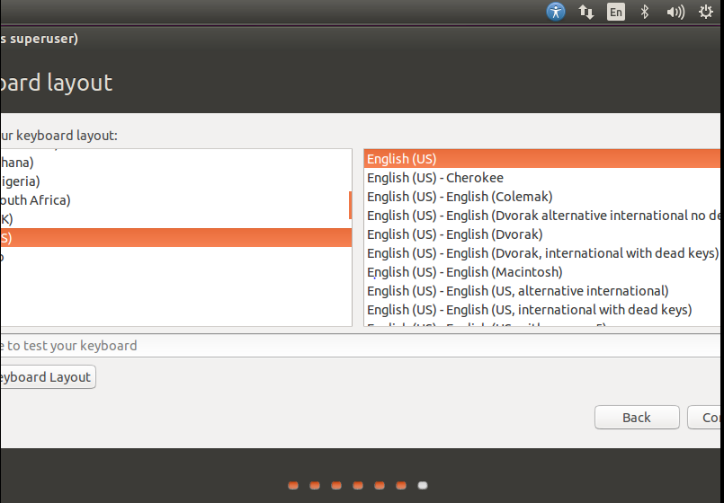

Fig(2.1a.7)

**Step 7-** In this you have to enter your information. Give your name in "Your name" box. Your computer's name means that this name is use when you talk with another computer. And fill the password. After finish of filling your information then click Continue.

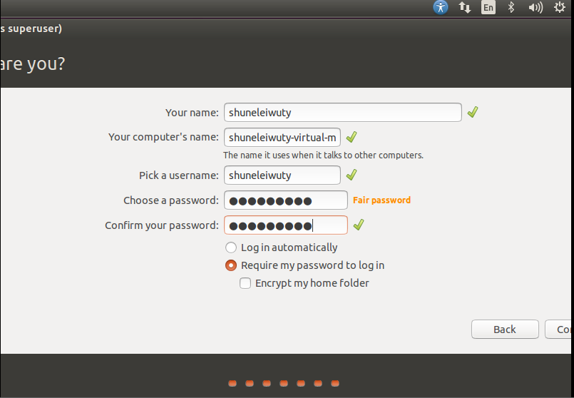

Fig(2.1a.8)

**Step 8-** Now the installation process is working and you have to wait until the process is complete.

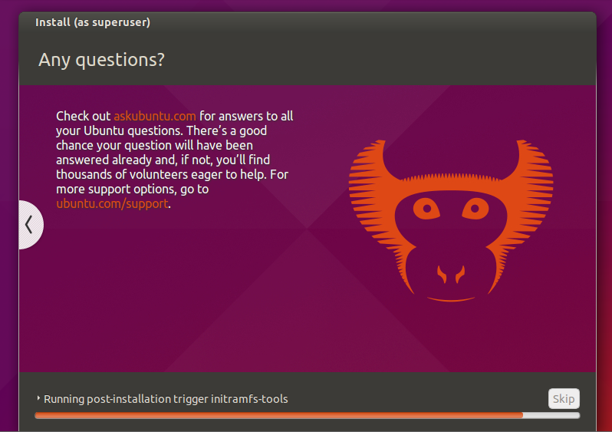

Fig(2.1a.9)

**Step 9-** After the installation of process is complete you will similar in the following. Then, click to "Restart Now".

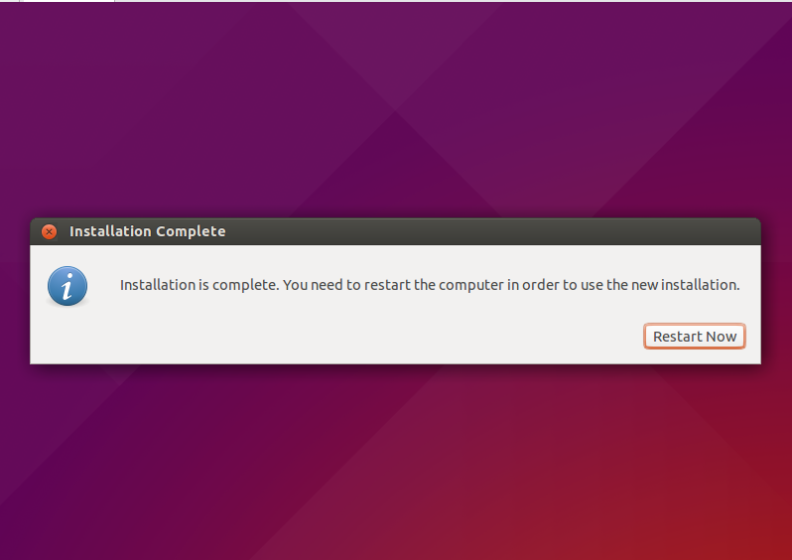

Fig(2.1a.10)

**Step 10-** When the pc is restarted. To sign in the window the system requires the password that you have been given in step-7. You can type the password and go on.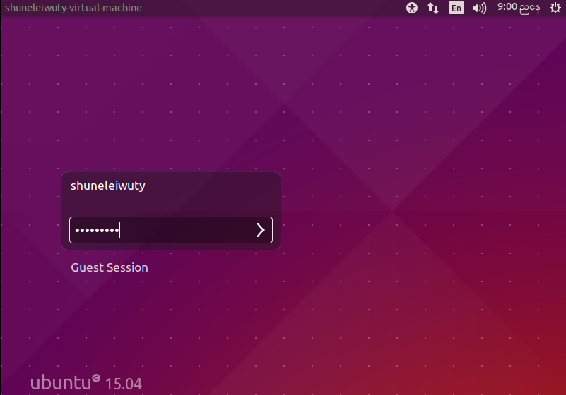

Fig(2.1a.11)

This is the Ubuntu desktop. The installation of Ubuntu Linux is all complete and use can use it now.

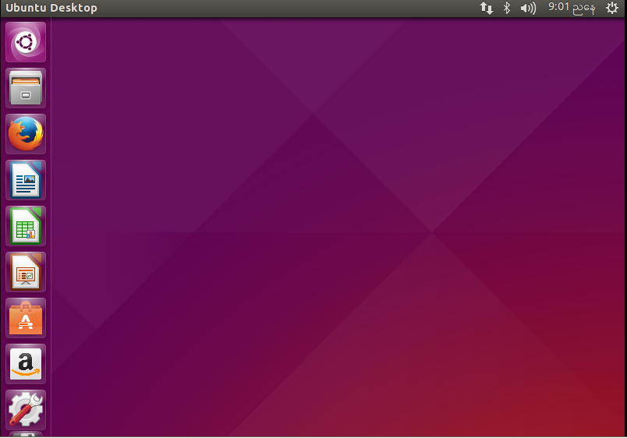

Fig(2.1a.12)

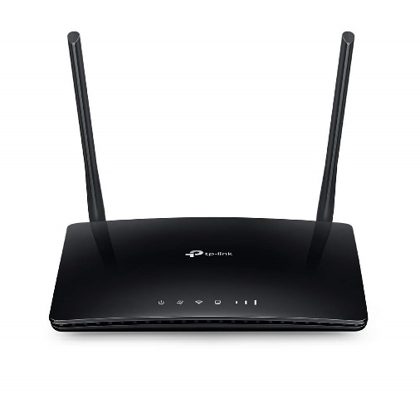

Price-$304.00

Model-TL-MR6400

Speed-300Mbps